Introduction to Project Management Assessment
Name
Matric number
2024
Contents
Work Breakdown Structure 2
Resource List 3
New World Training Gantt Screen Shot(Project1) 4
Meetings Task Explanation and Screen Shot(Project1-Meeetings) 4
Add a Cost Task Explanation and Screen Shot(Project1-FixedCost) 4
Identify Critical Path Explanation and Screen shot(Project-CriticalPath) 4
Part 2 Shorten Project Tasks 5
Explanation Scenario 1 Shorten Project 5
Explanation Scenario 2 Shorten Project 5

Work Breakdown Structure
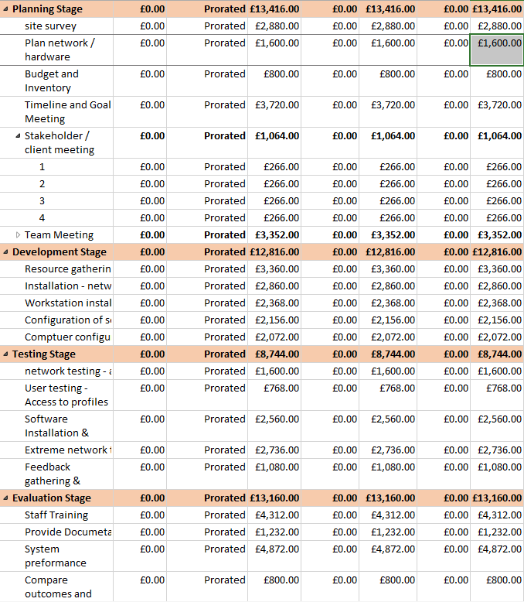

Resource List

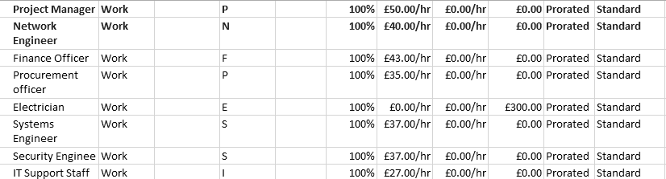

New World Training Gantt Screen Shot(Project1)
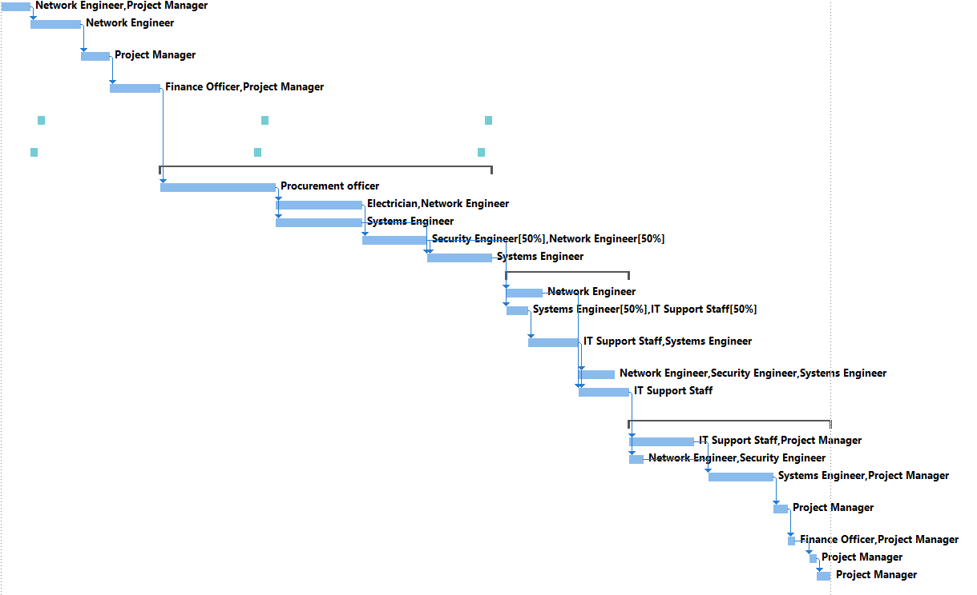

Meetings Task Explanation and Screen Shot(Project1-Meeetings)


Add a Cost Task Explanation and Screen Shot(Project1-FixedCost)

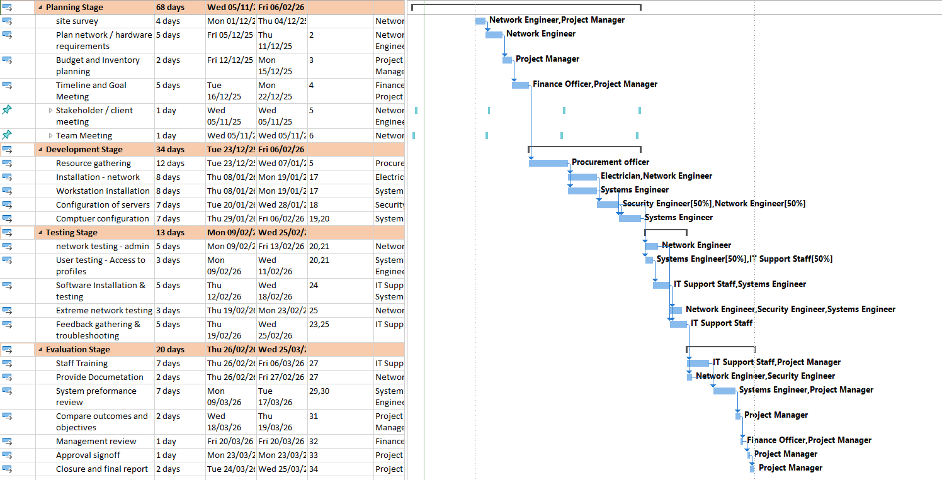
Identify Critical Path Explanation and Screen shot(Project-CriticalPath)
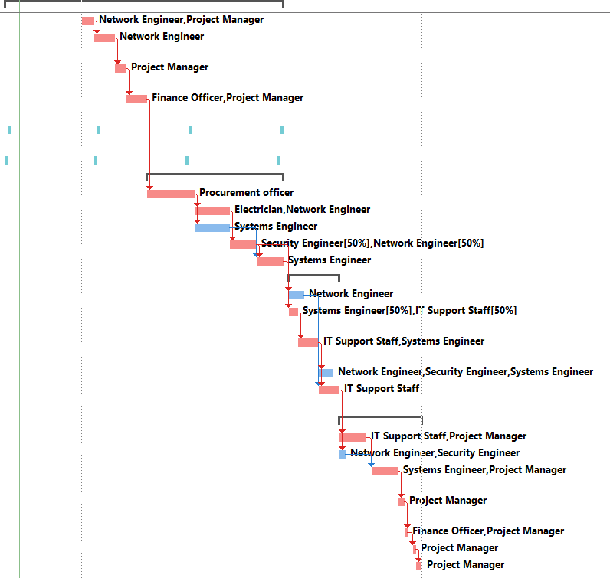

Part 2 Shorten Project Tasks

Explanation Scenario 1 Shorten Project

Explanation Scenario 2 Shorten Project

